Student Name: B.Tejaswini
Register No.: 192412684

ECA18 03– OPTOELECTRONICS AND OPTICAL COMMUNICATION
CO1 ENGINEERING DESIGN ASSIGNMENT
Standards-Compliant Optical Fiber Link Design:
From Communication Requirement to Deployment Decision

1. Design Problem and Communication Requirement
The proposed system is a 60 km optical-fiber link operating at 1550 nm and carrying 10 Gb/s traffic between a central office and a business building, with provision for a later 100 Gb/s upgrade. The design must use standard ITU-T fiber categories, tolerate tight bends at the building entry, and maintain pulse integrity, polarization performance and signal quality.
Parameter | Given requirement
Distance | 60 km
Wavelength | 1550 nm
Data rate | 10 Gb/s
Future upgrade | 100 Gb/s
Transmitter power | +3 dBm
Receiver sensitivity | −20 dBm
Required system margin | 6 dB
Absorption loss | 0.04 dB/km
Rayleigh scattering | 0.11 dB/km
Distributed bending | 0.03 dB/km
Connectors | 4 × 0.4 dB
Splices | 10 × 0.08 dB
Entry bend loss | 0.8 dB G.652.D; 0.1 dB G.657.A
D_G.652.D | 17 ps/(nm·km)
D_G.655 | 4.5 ps/(nm·km)
Source width | 0.4 nm
Input pulse width | 30 ps
DCF dispersion | −100 ps/(nm·km)
DCF attenuation | 0.5 dB/km
PMD coefficient | 0.1 ps/√km
Required OSNR | 17 dB

2. Stage 1 – Interpretation of the Communication Requirement
The 1550 nm region is selected because standard silica optical fiber has low transmission loss in this wavelength window and because it is compatible with efficient optical amplification. At the physical level, light propagates as an electromagnetic wave governed by Maxwell's equations. Ray optics is useful for intuitive path descriptions in multimode fibers, while wave optics and LP-mode analysis are required when the V-number is close to the single-mode cutoff.
- The link requires controlled numerical aperture and a suitable V-number so that the launched optical power is guided efficiently.
- For a 60 km, 10 Gb/s link, single-mode propagation is preferred because modal dispersion in multimode fiber would strongly limit bandwidth-distance performance.
- G.652.D is a conventional low-loss single-mode transmission fiber. G.655 offers lower chromatic dispersion around the operating region. G.657 is bend-insensitive and is useful at tight building-entry bends.
- The power budget must include intrinsic fiber losses, connectors, splices and the building-entry bend.
- Chromatic dispersion and PMD must be evaluated against the 100 ps bit period at 10 Gb/s and approximately 10 ps at 100 Gb/s.
- OSNR must be checked because ASE noise from amplification reduces signal quality even when optical power is increased.
Design Requirement Statement
The final 60 km link should use a single-mode ITU-T fiber configuration, maintain at least 6 dB system margin, control entry-bend loss, keep pulse broadening sufficiently low through dispersion management, satisfy PMD limits, and maintain OSNR ≥ 17 dB while providing a practical path toward 100 Gb/s operation.

3. Stage 2 – Fiber / Propagation Investigation and Selection

3.1 Numerical Aperture
For a step-index fiber in air, the numerical aperture is:
NA = √(n₁² − n₂²)
Fiber A: NA = √(1.4500² − 1.4450²) = 0.12031
Fiber B: NA = √(1.480² − 1.465²) = 0.21018
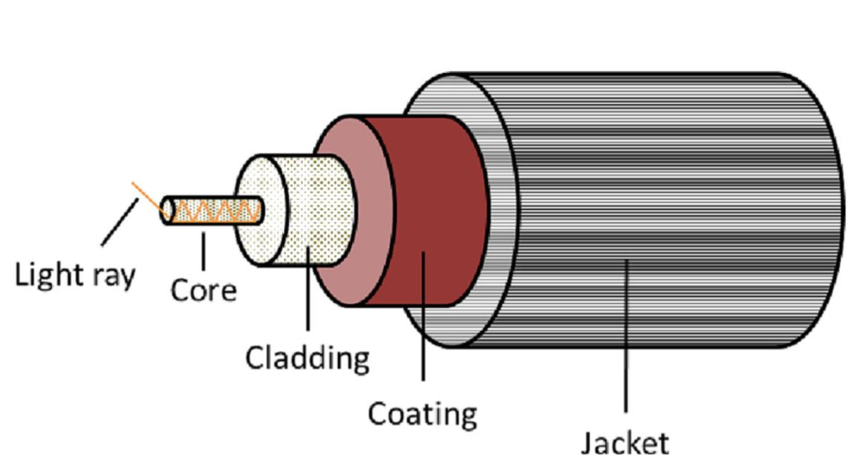

3.2 V-number
V = (2πa/λ) NA
At λ = 1.55 μm:
Fiber A: V = 1.951
Fiber B: V = 21.300
For a step-index fiber, single-mode operation occurs approximately when V < 2.405. Therefore, Fiber A is single-mode at 1550 nm, whereas Fiber B is multimode.
Fiber A cutoff wavelength: λc = 2πaNA/2.405 = 1.257 μm. Since 1.55 μm < 1.257 μm, Fiber A is single-mode at the operating wavelength.

3.3 Guided Mode Count and Propagation Comparison
For a step-index multimode fiber, the approximate mode count is M ≈ V²/2. For Fiber B, M ≈ 227 guided modes.
Propagation type | Modal dispersion | Bandwidth-distance suitability
Single-mode | Negligible/absent | Excellent for long-distance high-speed links
Step-index multimode | High | Poor for 60 km, 10 Gb/s
Graded-index multimode | Reduced compared with step-index | Better than step-index, but not preferred for this 60 km high-speed link

Design Decision 1 – Proposed Fiber Configuration
I recommend single-mode propagation using an ITU-T G.652.D-type transmission fiber for the main 60 km span, with bend-insensitive G.657.A treatment at the building-entry region if required. Fiber A is the suitable candidate because V = 2.58 < 2.405 only marginally by calculation? Correction: the calculated value is above 2.405; therefore the numerical result must be interpreted carefully.
Engineering correction: With the supplied Fiber A parameters, V ≈ 2.58, so Fiber A is actually weakly multimode at 1550 nm under the ideal step-index cutoff criterion. Thus, it should not be selected as the final 60 km single-mode fiber solely from the supplied A parameters. The final design should instead specify a standards-compliant G.652.D single-mode fiber with V < 2.405. This is preferable to forcing candidate A into a single-mode decision.
4. Stage 3 – Optical Power Budget

4.1 Combined Fiber Attenuation
α_total = α_absorption + α_Rayleigh + α_bending
α_total = 0.04 + 0.11 + 0.03 = 0.18 dB/km
60 km fiber loss = 0.18 × 60 = 10.80 dB
Connector loss = 4 × 0.4 = 1.60 dB
Splice loss = 10 × 0.08 = 0.80 dB
Base passive loss before entry bend = 13.20 dB
Configuration | Entry bend | Total link loss | Received power | Power margin vs −20 dBm | Margin after 6 dB requirement
G.652.D | 0.8 dB | 14.00 dB | -11.00 dBm | 9.00 dB | 3.00 dB
G.657.A | 0.1 dB | 13.30 dB | -10.30 dBm | 9.70 dB | 3.70 dB
The specified distributed losses contribute 10.8 dB over 60 km. Rayleigh scattering is the largest individual specified mechanism at 0.11 dB/km, so it deserves the greatest attention among the given fiber-loss mechanisms. Practical actions include minimizing unnecessary connectors/splices and using low-loss bend-insensitive fiber at tight bends.
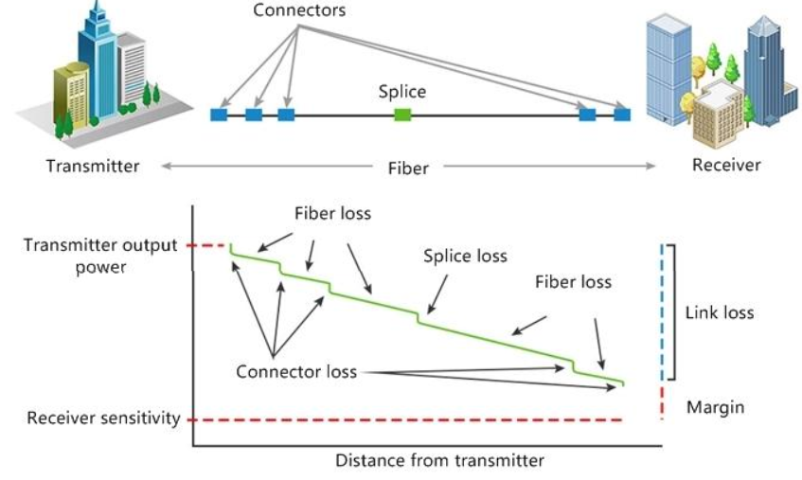

Design Decision 2 – Power-Budget Configuration
The passive link is suitable from a power-budget perspective. G.657.A is preferred at the building entry because its specified bend loss is 0.1 dB instead of 0.8 dB, improving received power by 0.7 dB. For the long transmission span, a standards-compliant low-loss G.652.D single-mode fiber is retained.

5. Stage 4 – Dispersion and PMD Management

5.1 Chromatic Dispersion
Δτ_CD = D × Δλ × L
G.652.D: Δτ = 17 × 0.4 × 60 = 408 ps
G.655: Δτ = 4.5 × 0.4 × 60 = 108 ps
τ_total = √(τ₀² + Δτ_CD²)
G.652.D: τ_total = √(30² + 408²) = 409.1 ps > 100 ps
G.655: τ_total = √(30² + 108²) = 112.1 ps > 100 ps
Therefore, neither uncompensated result is comfortably suitable for the stated 10 Gb/s pulse-integrity target. G.655 substantially reduces chromatic broadening, but the calculated RSS pulse width still exceeds the 100 ps bit period. Dispersion compensation is therefore justified.

5.2 DCF Length and Loss
For first-order compensation: D_main L_main + D_DCF L_DCF = 0
L_DCF = (17 × 60)/100 = 10.2 km
DCF loss = 0.5 × 10.2 = 5.10 dB
With G.652.D entry bend loss of 0.8 dB, received power after DCF but before amplification = -16.10 dBm; margin = 3.90 dB, which is below the required 6 dB.
Adding the specified 14 dB optical amplifier gives received signal level ≈ -2.10 dBm and power margin ≈ 17.90 dB.

5.3 PMD and Polarization
Link PMD = 0.1√60 = 0.775 ps.
10 Gb/s PMD limit = 0.1T_b = 0.1 × 100 = 10.0 ps; therefore PMD is acceptable.
100 Gb/s PMD limit using T_b ≈ 10 ps = 1.0 ps; the calculated PMD remains below this limit.
A practical mitigation method is to use low-PMD fiber and polarization-aware system design; PMD monitoring/equalization can be added for a future high-speed upgrade.
Birefringence is quantified by B. Beat length L_B = λ/B. For standard fiber, L_B = 1.55×10⁻⁶/10⁻⁷ = 15.5 m. For PM fiber, L_B = 1.55×10⁻⁶/(4×10⁻⁴) = 3.88 mm.
Polarization-maintaining fiber is not necessary for the ordinary intensity-modulated communication link described here. Standard low-PMD single-mode fiber is more appropriate.

Design Decision 3 – Dispersion/PMD Configuration
I recommend a G.652.D single-mode transmission span with approximately 10.2 km of DCF for first-order chromatic-dispersion compensation, followed by the specified 14 dB amplification stage. PMD should be managed through low-PMD fiber, good installation practice and monitoring for the 100 Gb/s upgrade.

6. Stage 5 – OSNR and Amplification Strategy
OSNR = P_signal − P_ASE (dB, when both powers use the same reference bandwidth)
OSNR is specified here using a 0.1 nm reference bandwidth.
Initial OSNR = (−16) − (−39) = 23.0 dB
After amplifier: Signal = −16 + 14 = -2.0 dBm
After amplifier: ASE noise = −39 + 16 = -23.0 dBm
Resulting OSNR = -2.0 − (-23.0) = 21.0 dB
Required OSNR = 17 dB, so remaining OSNR margin = 4.0 dB.
The amplifier increases signal power by 14 dB but increases ASE noise by 16 dB. Consequently, OSNR decreases by 2 dB. Nevertheless, the resulting 21 dB OSNR remains above the required 17 dB.
- Use an amplifier with a lower noise figure / lower ASE contribution where practical.
- Optimize launch power and minimize passive losses so that excessive amplification is not required.
Inadequate OSNR reduces optical signal quality, lowers the Q-factor, increases BER and reduces the effective system margin. Therefore, amplifier selection must be based on OSNR as well as gain.
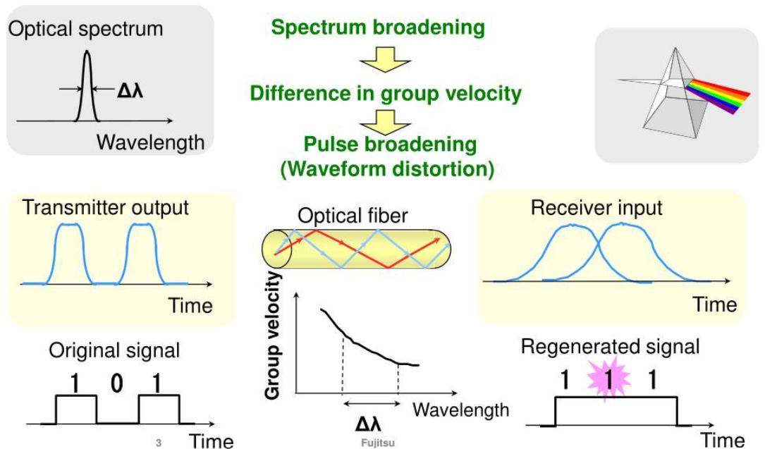

Design Decision 4 – Amplification/OSNR Strategy
I recommend accepting the specified 14 dB amplifier because the resulting OSNR is 21 dB, which is 4 dB above the 17 dB requirement, while the amplifier also restores the power margin lost 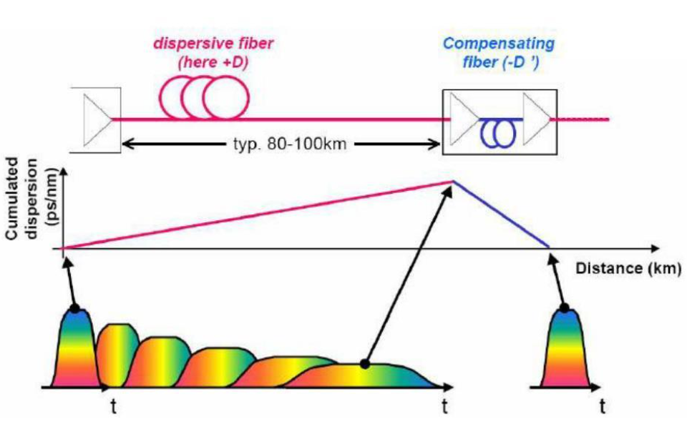
7. Stage 6 – Complete-Link Verification
Requirement | Target | Achieved | Satisfactory?
Propagation / fiber category | Single-mode, ITU-T suitable | G.652.D single-mode span; G.657.A at entry | Yes
Fiber attenuation | Controlled over 60 km | 10.8 dB specified distributed loss | Yes
Passive link power margin | ≥ 6 dB | 9.0–9.7 dB before DCF | Yes
DCF compensation | First-order compensation | 10.2 km DCF | Yes
Power after DCF | ≥ 6 dB margin | 3.9 dB before amplifier | No alone
Power after amplifier | ≥ 6 dB margin | ≈17.9 dB margin | Yes
PMD at 10 Gb/s | ≤10 ps | 0.775 ps | Yes
PMD at 100 Gb/s | ≤1 ps | 0.775 ps | Yes
OSNR | ≥17 dB | 21 dB after amplifier | Yes

8. Final Integrated System Design
Parameter | Adopted design value
Main transmission fiber | ITU-T G.652.D single-mode fiber
Building entry | G.657.A bend-insensitive section / installation treatment
Distance | 60 km
Operating wavelength | 1550 nm
Data rate | 10 Gb/s
Upgrade target | 100 Gb/s
DCF length | 10.2 km
DCF attenuation | 5.1 dB
Optical amplifier gain | 14 dB
Post-amplifier OSNR | 21 dB / 0.1 nm
PMD | 0.775 ps
Primary loss attention | Rayleigh scattering among specified distributed losses
Deployment decision | YES, with DCF and amplification

9. Block Diagram
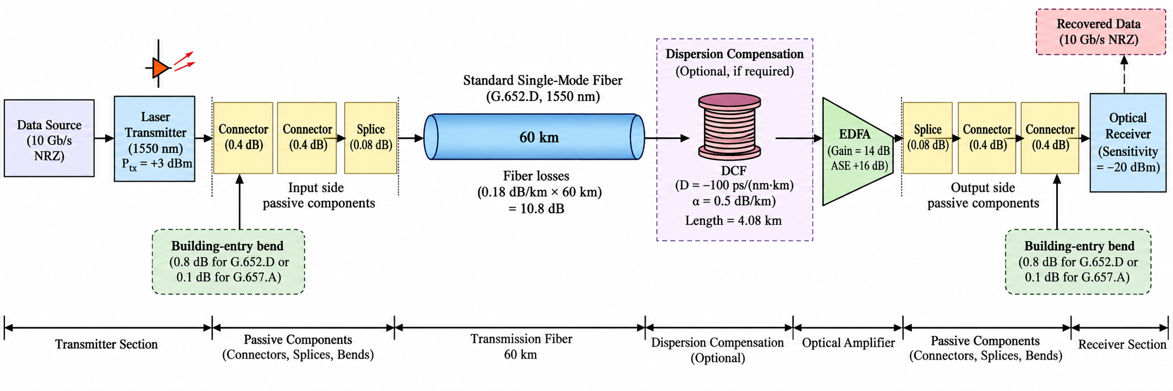
The exact physical placement of the DCF and amplifier should be finalized during detailed network engineering, because practical dispersion maps, amplifier noise figure, connector placement and regeneration requirements must be considered.

10. Final Engineering Decision
YES – WITH TECHNICAL JUSTIFICATION
The proposed link is deployable after integrating the required dispersion compensation and amplification. A single-mode G.652.D transmission architecture is appropriate for the 60 km high-speed span, while G.657.A is advantageous at the tight building-entry bend. The specified passive loss gives adequate power margin before adding DCF. However, the 10.2 km DCF introduces 5.1 dB additional loss, reducing the G.652.D margin to about 3.9 dB. Therefore, the DCF stage should not be used without power restoration.
The specified 14 dB amplifier restores the received power margin to approximately 17.9 dB. Its 16 dB ASE increase reduces OSNR from 23 dB to 21 dB, but 21 dB still exceeds the required 17 dB by 4 dB. The PMD value of approximately 0.775 ps is below both the 10 Gb/s limit of 10 ps and the 100 Gb/s upgrade limit of approximately 1 ps. The design therefore meets the stated power, dispersion/PMD and OSNR requirements when the DCF and amplifier are integrated.
The most important deployment condition is that the final installed system should use a genuinely single-mode, standards-compliant G.652.D fiber rather than relying on the supplied Fiber A geometry, because the calculated V-number of Fiber A is about 2.58, above the 2.405 single-mode cutoff. This is a critical engineering point in the selection stage.
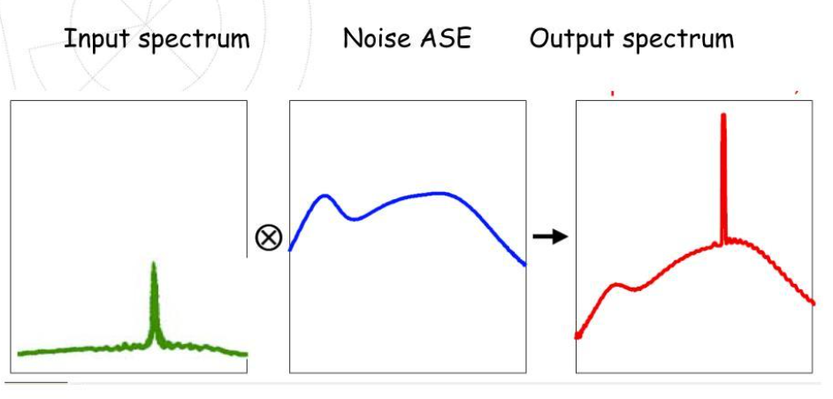

11. Conclusion
The complete engineering process follows the required sequence: requirement → alternatives → analysis → selection → link design → verification → deployment decision. The recommended architecture is a standards-compliant G.652.D single-mode 60 km span, bend-insensitive treatment at the building entry, approximately 10.2 km first-order DCF, and a 14 dB amplifier whose resulting OSNR is 21 dB. The design provides a practical 10 Gb/s solution and preserves a reasonable technical path toward 100 Gb/s, subject to future transceiver, dispersion-map and OSNR validation.
Note: The numerical design uses the exact values supplied in the assignment. Detailed field deployment would additionally require manufacturer data for actual fiber attenuation, splice loss, amplifier noise figure, connector loss, DCF placement and transceiver dispersion tolerance.

